**Garage Management system**

**1.Project Overview**

The Garage Management System (GMS) is a Salesforce application designed to streamline operations for automotive service centers. It enables efficient management of customer appointments, service records, and payment processing, enhancing the overall customer experience.

**2.Objectives**

The GMS aims to provide a comprehensive solution for managing garage operations such as vehicle servicing, maintenance scheduling, inventory management, customer relations, and employee task management. The system focuses on streamlining processes, enhancing service quality, improving operational efficiency, and delivering better customer experiences.

**Key Objectives:**

* **Automate and Streamline Operations:**
  + Automate service scheduling, task assignment, and technician dispatching to improve operational efficiency.
  + Reduce manual work and paperwork by digitizing service requests, invoices, and maintenance logs.
* **Efficient Inventory Management:**
  + Track spare parts and materials in real-time to reduce stock shortages and optimize inventory levels.
  + Automate low-stock alerts and streamline procurement processes for parts and materials.

**3. Salesforce Key Features and Concepts Utilized**

Salesforce provides a powerful suite of tools and capabilities that enhance the functionality of the GMS. The key features and concepts include:

* Managing customer appointments
* Tracking service records
* Processing payments
* Providing a user-friendly interface

**4. Detailed Steps to Solution Design**

**Requirement Gathering:**

* Identify key features such as customer management, vehicle tracking, service scheduling, inventory, billing, and reporting.

**System Analysis:**

* Analyze existing processes for service tracking and inventory management.
* Identify inefficiencies and automation opportunities.

**Define Architecture in Salesforce:**

* **Modules:**
  + Customer Management: Store customer and vehicle details.
  + Service Management: Schedule and track service requests.

**Data Model Design:**

* **Key Custom Objects:**
  + Vehicle: Linked to Account (Customer).
  + Service Request: Tracks service details and technician assignment.

**User Interface Design:**

* Use Lightning Experience for:
  + **Admins:** Service dashboards, inventory management.
  + **Technicians:** Service assignment and status updates.

**Business Logic Implementation:**

* **Flows and Process Builder:**
  + Automate service scheduling and notifications.
* **Apex Triggers:**
  + Deduct inventory when a service is completed.

**Integration and Automation:**

* Integrate payment gateways (e.g., Stripe) for invoice payments.
* Use email and SMS notifications for booking updates.

**Prototyping and Validation:**

* Build a prototype in Salesforce Sandbox.
* Validate workflows for booking, service, and billing.

**Deployment:**

* Deploy to production using Salesforce Change Sets.
* Migrate existing customer and vehicle data.

**Monitoring and Optimization:**

* Use Salesforce Reports and Dashboards to monitor performance.
* Gather feedback and iterate for continuous improvement.

**5. Testing and Validation**

1. **Unit Testing:**
   * Validate individual components (e.g., custom objects, Apex classes).
2. **Functional Testing:**
   * Test specific business workflows for correctness.
3. **Integration Testing:**
   * Validate interactions with external systems or services.
4. **User Acceptance Testing (UAT):**
   * Ensure the system meets user expectations.
5. **Regression Testing:**
   * Ensure existing functionality remains unaffected after updates.

**6. Key Scenarios Addressed by Salesforce in the Implementation Project**

1. **Customer and Vehicle Management:**
   * **Scenario:** Manage customer details and their associated vehicles.
   * **Salesforce Solution:**
     + Use Accounts and Contacts to manage customer information (e.g., name, contact details).
     + Create a custom object Vehicle linked to the customer account to store details like VIN, make, model, and year.
2. **Service Booking and Scheduling:**
   * **Scenario:** Customers need to book and schedule service appointments for their vehicles.
   * **Salesforce Solution:**
     + Use custom workflows and Lightning Scheduler for appointment management.
3. **Technician Management:**
   * **Scenario:** Assign technicians to service requests based on availability and expertise.
   * **Salesforce Solution:**
     + Use resource management tools within Salesforce to track and assign tasks.
4. **Inventory and Spare Parts Management:**
   * **Scenario:** Track inventory levels for spare parts and manage stock availability.
   * **Salesforce Solution:**
     + Implement custom objects and workflows to manage inventory and set low-stock alerts.
5. **Invoicing and Payments:**
   * **Scenario:** Generate and manage invoices for completed services.
   * **Salesforce Solution:**
     + Integrate payment gateways for seamless transaction processing.
     + Use Salesforce Reports for invoicing and revenue tracking.

**7. Screenshots**

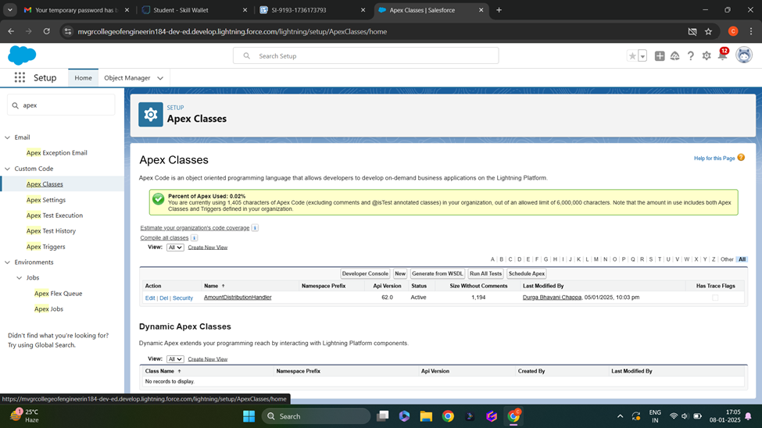

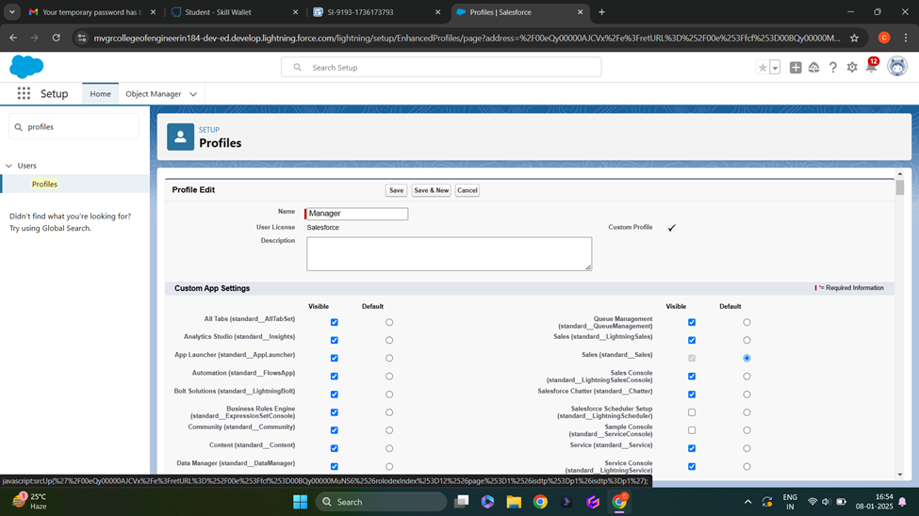

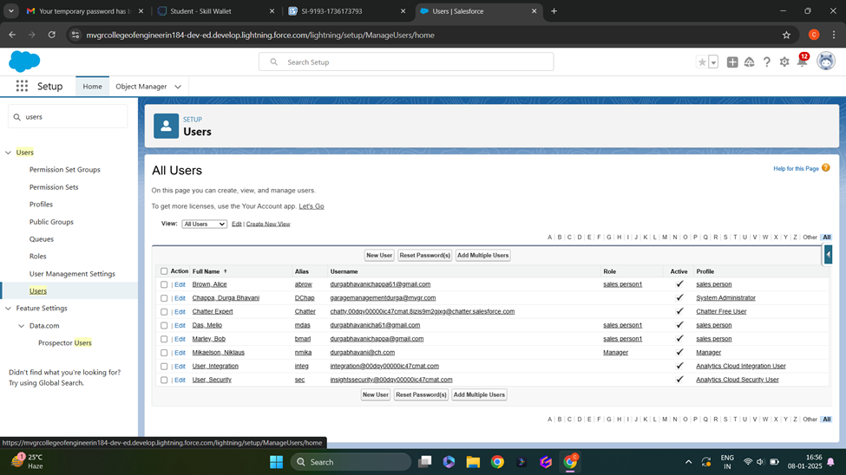

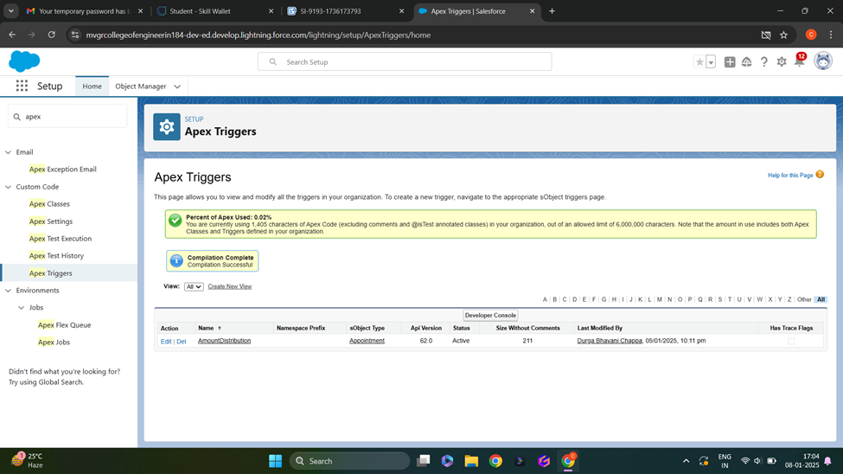

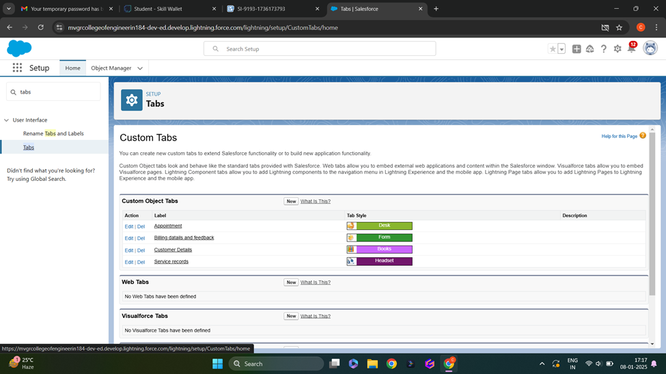

**8. Conclusion**

The Garage Management System effectively streamlines essential operations, including customer and vehicle management, service scheduling, inventory tracking, invoicing, and reporting. By utilizing Salesforce's robust capabilities—such as custom objects, workflows, automation, and Experience Cloud—the system enhances operational efficiency, ensures data accuracy, and delivers an improved customer experience. With its scalable and secure architecture, the solution not only addresses current business requirements but also lays a strong foundation for future expansion and innovation.